Name ____________________________ Date_______________ Period_____
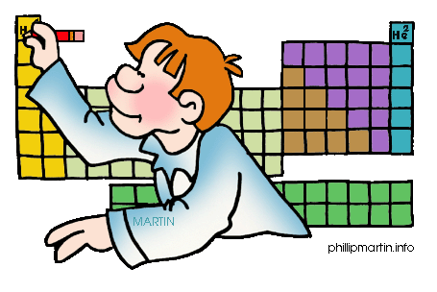
Periodicity Organizer
Using your knowledge of the trends associated with the periodic table, fill in the organizer below.
Trend | Definition | Periodic Trend Pattern
Atomic Radii
Electronegativity
Ionic Radii
Ionization Energy

